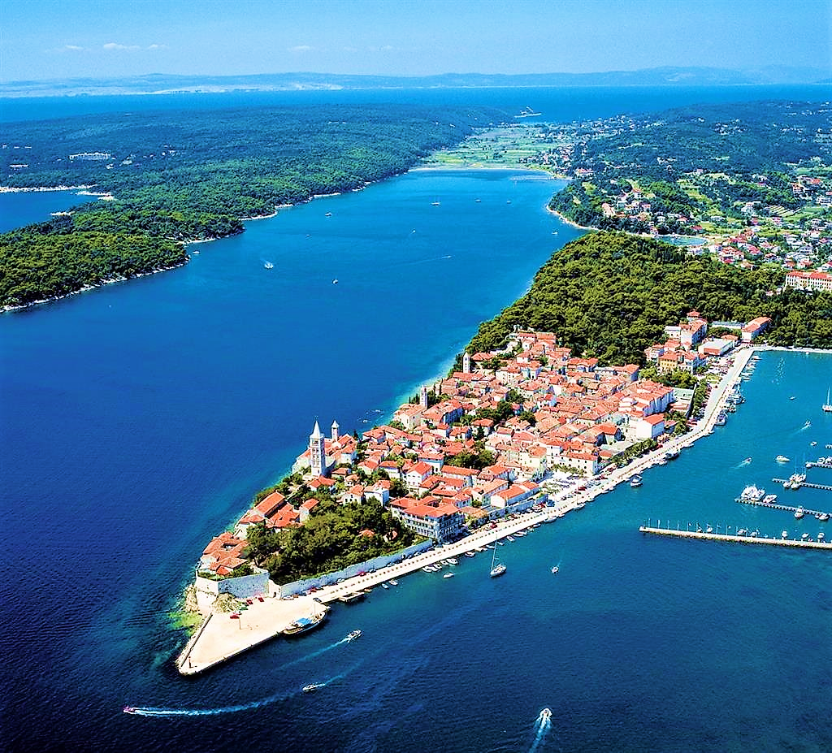
RAB HARP SUMMER COURSE / JULY 12 - 21, 2019
RAB LJETNI MAJSTORSKI TEČAJ HARFE / 12 - 21 SRPANJ, 2019
Chantal MATHIEU, Harp * Harfa
&
Tajana VUKELIĆ PEIĆ, Harp ensemble * Ansabl harfi

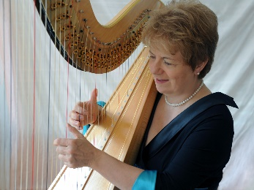
registraTION form * OBRAZAC ZA PRIJAVU
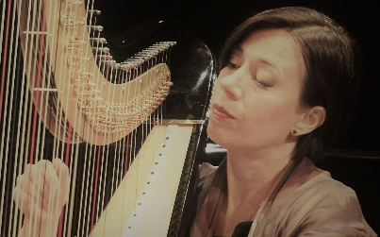
to be sent to * Poslati na
tajanavukelic@harfacroatia.com

REGISTRATION DEADLINE: JUNE 01, 2019 * ROK ZA PRIJAVU: 01. LIPNJA 2019
10% discount for registration before April 15th * 10% popusta za registraciju prije 15. travnja

Name & Last name / Ime & Prezime: …………………………….…………………….……………………………………………….………………………..……………………...
Address / Adresa: …………………………………………………………….…………………………………………..………………………………….……………………………………………….…
Zip code / Poštanki br: …………………………………………… City / Grad: ………….…………………………….…………………..………………………….…………………
Country / Zemlja: ………………………………………………………Tel.: …………………………………………………………………………….…………….………………………………
E-mail: …………………………………………………………………………………….………………………………………………………… Age / Dob: …………………………………………...
Teacher / Profesor: …………………………………………………….……………………… Level / Razina učenja:…………………….……………………………………
Prijavljujem se za ljetni tečaj kao: (Molim označite √ za odgovor)
Aktivni sudionik
Slušaoc
Prilažem kopiju potvrde o uplaćenih …………………..…………………..Euros
Potrebna mi je: Pedalna harfa Mala harfa s kukicama Donosim harfu

I register to the Summer Course as: (Please tick √ your answer)
Active participant
Listener
I enclose copy of my payment of …………………………………………..… Euros
I need a: Pedal harp Celtic harp I bring my harp

Datum / Date: ………………………….………………………………… Potpis / Signature: ……………………………………………………………………………….………

